1. Retrieve all employee records

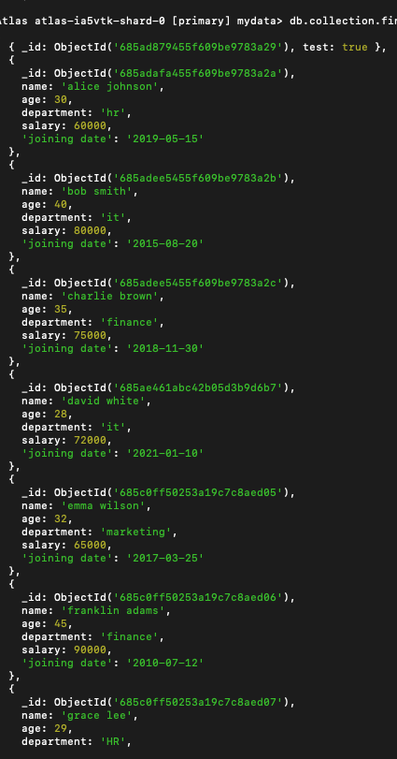

1. Employees who work in it department

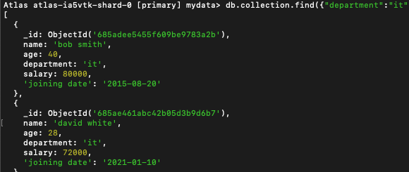

1. Employees who have salary greater than 70,000

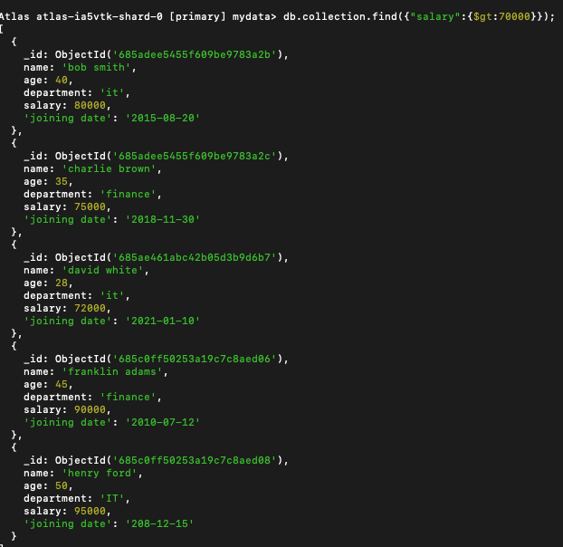

1. Employees who joined after 2018

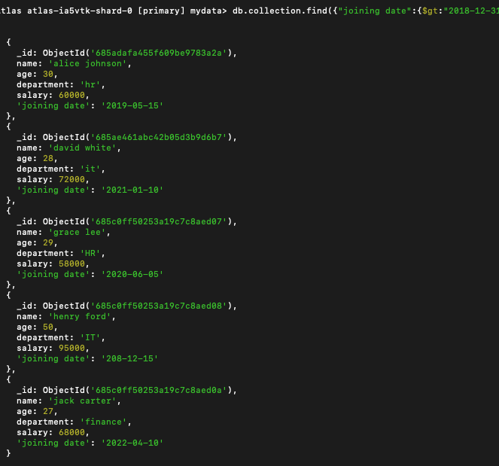

1. Employees whose age is between 30 and 40



1. Increase the salary in finance department by 5%

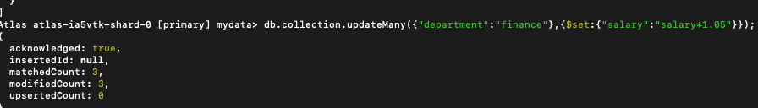

1. Delete employees who joined before 2010



1. Highest paid employee

